**Exercise 7 : Database Modeling Relationships**

Hotel (hotelNo, hotelName, city)

Room (roomNo, hotelNo, type, price)

Booking (hotelNo, guestNo, dateFrom, dateTo, roomNo)

Guest (guestNo, guestName, guestAddress)

Where Hotel contains hotel details and hotelNo is the primary key;

Room contains room details for each hotel and (roomNo, hotelNo) forms the primary key;

Booking contains details of bookings and (hotelNo, guestNo, dateFrom) forms the primary key;

Guest contains guest details and guestNo is the primary key.

**3.8 Identify the foreign keys in this schema. Explain how the entity and referential integrity rules apply to these relations.**

Room database tabellen skal have en foreign key (fk_hotel), som sammenkæder hotelNo fra Hotel databasetabellen.

Booking database tabellen skal have 3 foreign key (fk_hotelNo, fk_guest, fk_roomNo), som sammenkæder hotelNo fra Hotel databasetabellen, guestNo fra Guest databasetabellen og til sidst fra roomNo databasetabellen Room.

***Forskellen ved entity og referential rules:***

Ved entity rules gælder at en primary key ikke kan være nul.

Er et database koncept som gør at relationer mellem tabellerne bliver konsekvente. Når en tabel har en foreign key til en anden tabel betyder begrebet referential integrity at man ikke kan føje ny data til den tabel der indeholder din foreign key medmindre der findes tilsvarende data i den anden sammenkædet tabel.

**3.11 Implement the above schema in one of the RDBMSs you currently use, implement, where possible, the primary key, alternate and foreign keys, and appropiate relational integrity con straints.**

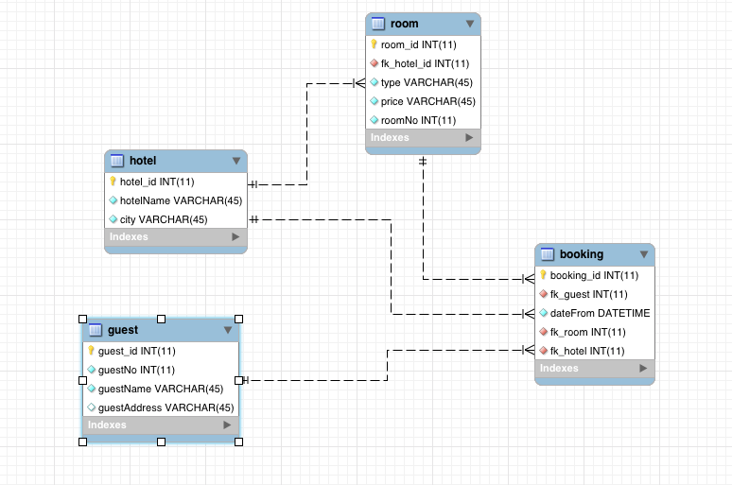

**Zalando table relationships**

